**Project : Part 2 Course : Software Engineering - CS301**

**Group exercise : 30th Jan 2023 to 2nd Feb 2023,8 PM**

**Team Size : Same team as Part 1**

**Deliverable/Report : Use case diagram, Class diagram and Sequence diagram**

**Submission Deadline : Submission to GitHub latest by 8.30 PM, 2nd Feb 2023**

**-------------------------------------------------------------------------------------------------------------------------**

**ZENZONE**

**TEAM MEMBERS :-**

**Riddhish Ganesh Mahajan(21BCS094)**

**Sahil Kirti(21BCS097)**

**Shivam kumar(21BCS112)**

**PART A : Detail study and analysis of Requirements elicitation**

**Project scope:**

The scope of a meditation and mindfulness app project will depend on the specific needs of the user. Generally speaking, the scope of a project may include the development of a mobile or web application that provides guided meditation and mindfulness practices, educational content, and tracking and reporting features. Additionally, the project may include the integration of additional features, such as social sharing, online communities, and gamification. The scope of the project may also include the development of a marketing and promotional strategy for the app.

**Functional requirements:**

1. Ability to create an account/sign in/sign out: Users should be able to create an account and log in and out of the app.

2. Ability to access meditation/mindfulness content: Users should be able to access meditation and mindfulness content.

3. Ability to track progress: Users should be able to track their progress in terms of the amount of time they’ve spent meditating, the type of content they’ve accessed, and any other metrics deemed important.

4. Ability to set goals: Users should be able to set goals for themselves, such as a specific amount of time to meditate each day.

5. Ability to receive notifications and reminders: Users should be able to receive notifications and reminders about upcoming meditation sessions or goals.

6. Ability to customize content: Users should be able to customize the content they receive, such as the types of meditation and mindfulness exercises they’re interested in.

7. Ability to connect with other users: Users should be able to connect with other users in the app, such as friends, family members, and other like-minded individuals.

8. Ability to access in-app resources: Users should be able to access**.**

**Non-functional requirement**

1. Performance – The application should be able to respond to user requests within a reasonable time limit.

2. Security – The application should use secure authentication protocols to prevent unauthorized access to user data.

3. Availability – The application should be available to users 24/7.

4. Compatibility – The application should be compatible with multiple platforms and devices.

5. Usability – The application should be user-friendly and easy to use.

6. Scalability – The application should be able to handle an increasing number of users.

7. Maintenance – The application should be easy to maintain and update.

8. Accessibility – The application should be accessible to users with disabilities.

**USE CASE DIAGRAM**

**Pre and Post conditions for all use cases:-**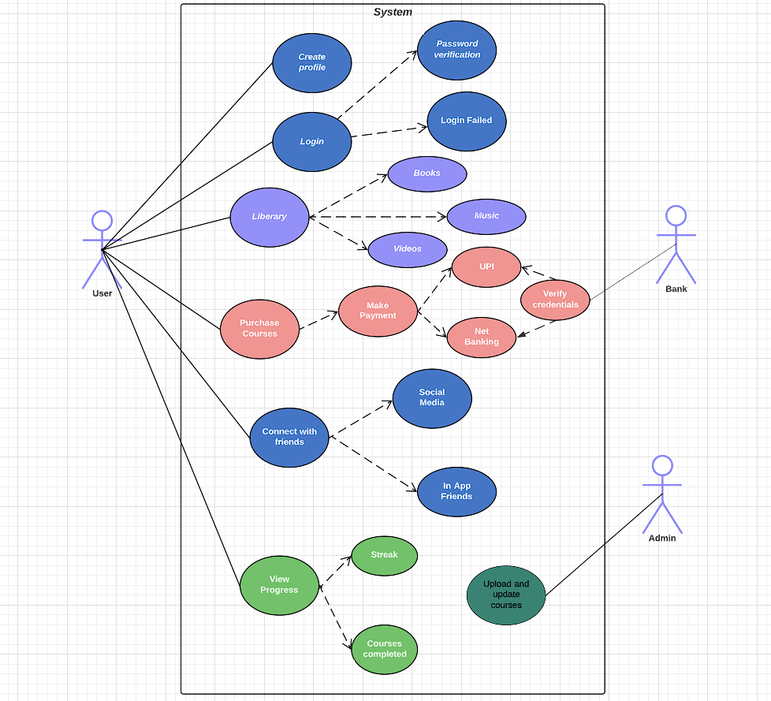

| ***Use cases*** | ***Pre conditions*** | ***Post conditions*** |
| --- | --- | --- |
| Create profile | User must be using the app for the first time. | User can now login to his/her profile anytime by using his/her unique UserID and Passcode |
| Library | If the user wants to get guide to meditation and relaxation | User can now access books ,videos, and music related to meditation |
| Purchase Courses | If user wants to get training from professionals and want a structured course . | User can buy courses across the app based on his/her requirement and needs. |
| Connect with friends | If user want to compete with their friends or share his/her achievement on social media | User can now showcase his/her achievements through this feature. |
| View Progress | If user wants to have a look over his/her past performance and history,or want to see the courses completion status. | User can now analyze his/her consistency and performance to get most of the guided meditation courses . |

**Class Diagram**

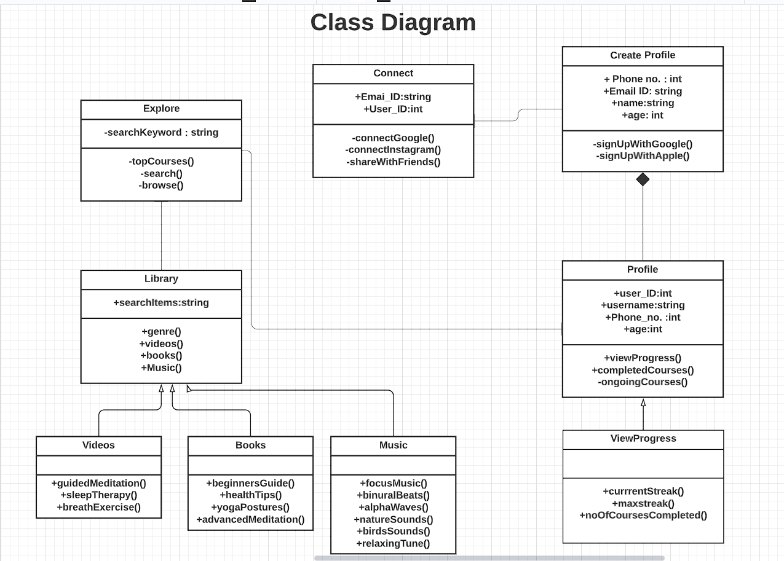

**Sequence diagram**

